TASK-15

How can I access an EC2 instance if the key pair file is deleted?
Step 1: Create an AMI (Amazon Machine Image) from the Instance
- Select the stopped instance.
- Click Actions → Image and templates → Create image.
- Give the image a name and description.
- Click Create Image.
- Wait until the AMI creation is completed (check in AMIs section).
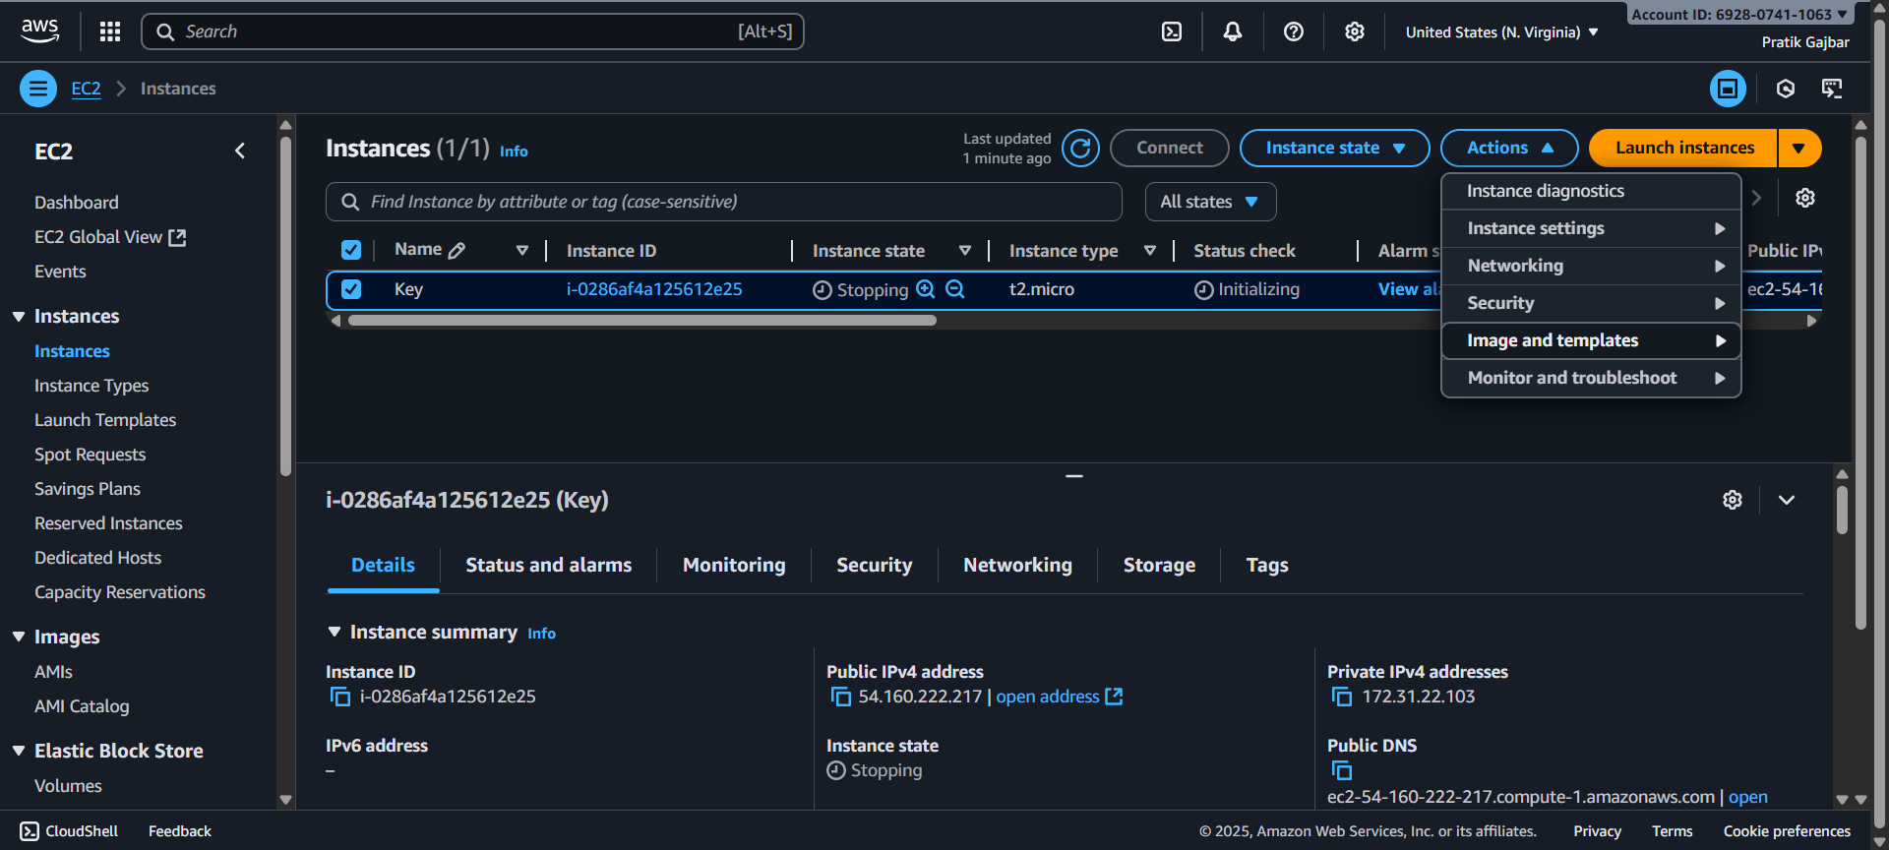
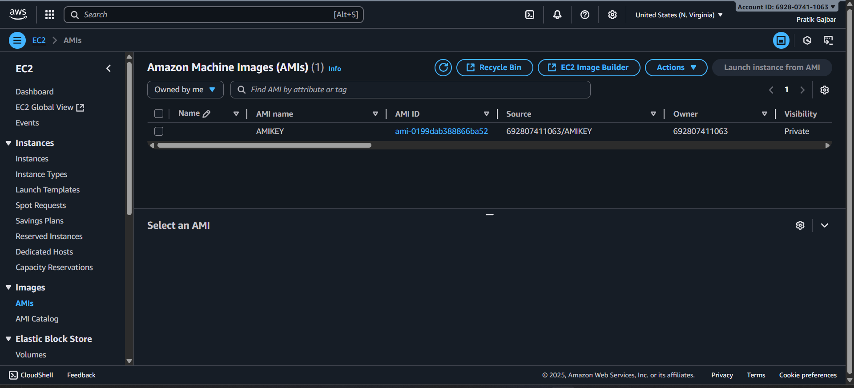

Step 2: Launch a New EC2 Instance Using a New Key Pair
- Go to EC2 → AMIs → select your newly created AMI.
- Click Launch instance from image.
- Choose instance type, configure network settings, etc.
- Create a new key pair.

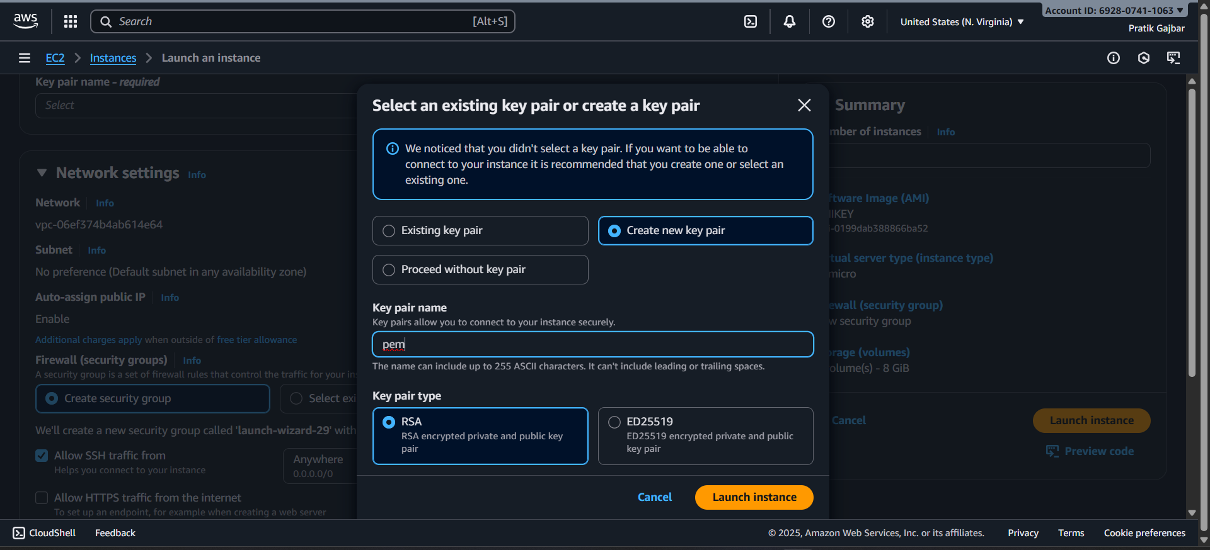

- Download the new key pair (.pem file) and keep it safe.
- Launch the instance.

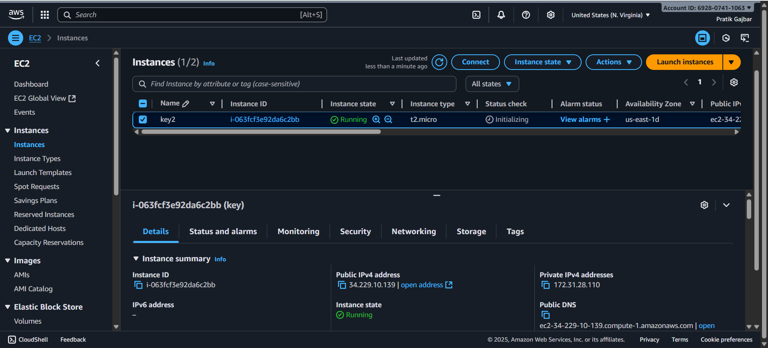

Step 3: Access the New Instance
  - Once the new instance is running, copy its public IP.
  - Use SSH to connect:
ssh -i "new-key.pem" ec2-user@<PUBLIC_IP>
Replace new-key.pem with downloaded key.

